

**JOMO KENYATTA UNIVERSITY OF AGRICULTURE AND TECHNOLOGY**

**SCHOOL OF ELECTRICAL, ELECTRONIC AND INFORMATION ENGINEERING**

**DEPARTMENT OF TELECOMMUNICATION AND INFORMATION ENGINEERING**

**PROJECT PROPOSAL**

**BETA CLIFFORD WILSON**

**EN273-0628/2013**

**ANNE OKEMWA**

**EN273-6120/2014**

**ADAPTIVE BEAMFORMING FOR FUTURE INTELLIGENT TRANSPORTATION SYSTEMS**

A research proposal submitted to the Department of Telecommunication and Information Engineering in partial fulfillment of the requirements for the award of the degree of Bachelor of Science in Telecommunication and Information Engineering.

**January 2018**

# DECLARATION

This project proposal is my original work, except where due acknowledgement is made in the text, and to the best of my knowledge has not been previously submitted to Jomo Kenyatta University of Agriculture and Technology or any other institution for the award of a degree or diploma.

NAME: BETA CLIFFORD WILSON

REG. No.: EN273-0628/2013

SIGNATURE: ............................................... DATE: ....................................................

NAME: ANNE OKEMWA

REG. No.: EN273-6120/2014

SIGNATURE: ............................................... DATE: ....................................................

PROPOSAL TITLE: INTELLIGENT GSM ENABLED FIRE SUPPRESSION SYSTEM IN DATA CENTERS

PROGRAMME: BACHELOR OF SCIENCE IN TELECOMMUNICATION AND INFORMATION ENGINEERING

**SUPERVISOR CONFIRMATION:**

This project proposal has been submitted to the Department of Telecommunication and Information Engineering, Jomo Kenyatta University of Agriculture and Technology, with my approval as the supervisor:

ROBERT MACHARIA MAINA Signature: ......................... Date: ...........................

# 

# ABSTRACT

Millimetre Wave (mmWave) systems have the potential of enabling multi-gigabit-per-second communications with very low latency in future Intelligent Transportation Systems.

Unfortunately, due to increased vehicular mobility, there is need of frequent antenna beam realignments, thereby significantly increasing the in-Band beam forming overhead. In this paper we propose motion prediction and beam alignment algorithm that exploits the information broadcast by all vehicles via DSRC beacons.

Based on the information broadcast, overhead free Beam-Forming is achieved using a Recurrent Neural Network to predict vehicle motion and estimating position, the beamwidth is then adjusted with respect to the estimated position.

We hope to demonstrate that the suggested approach is more efficient that the current approaches to beam steering and has the potential of increasing the data rates and the quality of service (QoS).

Keyword: mmWave, Vehicle-to-Everything Communications, Neural Network, Beamforming.

TABLE OF CONTENTS

DECLARATION ii

ABSTRACT iii

**TABLE OF CONTENTS** iv

LIST OF FIGURES vi

LIST OF TABLES vi

LIST OF ABBREVIATIONS vi

CHAPTER 1 1

1 INTRODUCTION 1

1.1 BACKGROUND 1

1.2 PROBLEM STATEMENT 1

1.3 JUSTIFICATION 1

1.4 OBJECTIVES 1

1.4.1 MAIN OBJECTIVE 1

1.4.2 SPECIFIC OBJECTIVES 1

CHAPTER 2 1

2 LITERATURE REVIEW 1

2.1 INTRODUCTION 1

2.2 FIRE SUPPRESSION SYSTEMS 1

CHAPTER 3 1

3 METHODOLOGY 1

CHAPTER 4 1

4 EXPECTED RESULTS 1

BUDGET 1

WORKING SCHEDULE 2

REFERENCES 2

# LIST OF FIGURES

**No table of figures entries found.**

# LIST OF TABLES

**No table of figures entries found.**

# LIST OF ABBREVIATIONS

AAAS ………………. Adaptive Antenna Array System

AI……………………. Artificial Intelligence

BER…………………. Bit Error Rate

CGA………………….. Conjugate Gradient Algorithm

CMA ………………... Constant Modulus Algorithm

DDA...……………….. Decision Directed Algorithm

DOA………………….. Direction of Arrival

FGA………………….. Fuzzy Genetic Algorithm

GA………………….. Genetic Algorithm

GSM…………………. Global System for Mobile Communications

[LMS](http://en.wikipedia.org/wiki/Least_mean_squares)…………………. Least Mean Squares

MMSE……………….. Minimum Mean Square Error

PSO………………… Particle Swarm Optimization

RLS…………………. Recursive Least Squares

SINR…………………. Signal to Interference and Noise ratio

# CHAPTER 1

# INTRODUCTION

## BACKGROUND

Connected and Autonomous Vehicles(CAVs) will as key entities for the Next-Generation Intelligent Transportation System (ITS) applications and services. The trend toward autonomous vehicles is transforming how cars are designed and marketed. Vehicles are gradually being equipped with more sensors, there is also a shift in emphasis from car exteriors to interiors, and a shift from engine performance to personalized passenger experiences. Vehicles are also getting connected to each other, to users, and to infrastructure.

Data from the onboard sensors can be shared with other vehicles to understand traffic conditions and improve navigation quality. The same data can be shared with the infrastructure network and used for efficient resource allocation.

The next generation of automotive application such as Virtual reality and Augmented reality place the highest demand on network resources and quality. For instance, they require gigabit-per-second data rates, extreme low latency and very high quality of service(QoS).

All these network requirements can be delivered by mmWave systems had it not been that increased vehicular mobility as well as the propagation characteristics of these systems lead to performance degradation due to Doppler Shifts and frequency misalignments.

As a solution, we propose a hybrid approach to beamforming leveraging Dedicated Short Range Communication and Millimeter Wave Radio Access Technologies. Information broadcast from the vehicles using DSRC are used to initialize a prediction algorithm to estimate the vehicle positon and the beam in steered in that direction.

## PROBLEM STATEMENT

Millimeter Wave systems hold the promise for the future of communications as well as the potential for creating an immense value chain in Telecommunications. There are three families of use case scenario applications for these systems, namely:

* Massive machine-type communications which require connectivity for millions of devices which transmit low volume, non-delay sensitive data.
* Critical machine-type communications for ultra-reliable, resilient, instantaneous connectivity with stringent requirements for capabilities such as throughput, latency and availability.
* Enhanced mobile broadband for mass mobile connectivity as demand for mobile broadband continues to increase.

In the future Intelligent Transportation Systems (ITSs), these use cases are present, for instance,

* Vehicles will need to share trip data, diagnostic reports and other information which may not be critical with the owners and the manufacturers – the Internet of Moving Things
* Autonomous driving requires ultra-reliable, resilient and instantaneous connectivity to be able to handle the caprice of daily driving.
* Vehicles are slowly transitioning into infotainment devices as well which puts heavy demands on mobile broadband due to applications such as AR and VR.

Increased vehicular mobility leads to performance degradation due to Doppler shifts and frequency misalignments. Such could adversely affect the critical machine-type communication as well as the overall mobile user experiences as they drive along.

Consequently, there is need for constant beam steering increasing the in-band beam forming overhead.

In this paper, we propose a novel approach to beam steering which involves the use of a RNN to predict vehicle position and steering the beam in the predicted direction. Information between the vehicles and the infrastructure network will be exchanged via DSRC beacons.

## JUSTIFICATION

Cellular networks of the second (2G), third 3(G) and fourth (4G) are optimized to support high loads of static users with spectrum and power constraints.

In the recent past, however, there has been a steady increase in vehicular communications. This has led to the development of a powerful concept which is only useful for slow moving users: “channel state information at the transmitter”(CSIT).

The main idea is the transmitter is informed of the current radio conditions between itself and the receiver, consequently the transmitter adapts its transmission to the current radio conditions and increases its efficiency in terms of spectrum usage and or power consumption.

Unfortunately, the CSIT of a fast moving user will be outdated and useless, due to the delay between the time when the channel is measured and the time when it is available at the

transmitter.

More recent approaches to beamforming involve a three step process:

* Sector level sweep (SLS)
* Beam-refinement protocol(BRP)
* Beam tracking

Unforunately, such an approach significantly increases the in-band beamforming overhead and for fast moving targets, the beam misalignments are frequent.

In order to:

1. ensure overhead-free beamforming
2. reduce the association delays during beamforming
3. minimize the beam misalignments
4. enhance mmWave performance

we propose a neural network based approach to beamforming involving a predictor antenna and out of band exchange of information between the vehicular target and the transmitter.

## OBJECTIVES

### MAIN OBJECTIVE

To achieve the highest data rates and best Quality of Service (QoS) for vehicular targets by using Neural Networks to predict vehicular motion and subsequent beam steering

### SPECIFIC OBJECTIVES

1. To model vehicle motion as a sequence
2. To train a Recurrent Neural Network to predict vehicle motion
3. To simulate linear array beamforming
4. To use predicted vehicle positions for beam steering
5. To achieve overhead-free beamforming

# 

# CHAPTER 2

# LITERATURE REVIEW

## INTELLIGENT TRANSPORTATION SYSTEMS

Connected and Autonomous Vehicles (CAVs) will act as key entities for Next-Generation Intelligent Transportation System (ITS) applications and services. Vehicles being gradually

equipped with more sensors, will have the potential of enhancing transportation safety and reaching full autonomy (al, 2014)

ITS’s are a convergence of many fields, for example transport and travel information might be viewed under a smart cities agenda and similarly “Connected cars” are a manifestation of Machine-to-Machine (M2M) communication and the Internet of Things (IoT), automated billing and charging of certain fees is a concern of the financial sector and may involve mobile money transfer etc.

### CONNECTED AND AUTONOMOUS VEHICLES (CAVS)

“Connected car” penetration will increase globally from 11% in 2012 to 60% in 2017 (and

to more than 80% in the United States and Western Europe).

Connected vehicles can communicate with each other and their surroundings. They are equipped with internet access, cellular radio, radar and other communication links including DSRC and an internal wireless local area network, allowing internet access to other devices both inside and outside the vehicle. Benefits to the driver include prevention or automatic notification of crashes, speeding and congestion. Increasingly, connected cars use smartphone apps to interact with the car from any distance. Users can unlock their cars, check the status of batteries on electric cars, find the location of the car, or remotely activate the climate control system.

The connected vehicle market continues to grow rapidly. Advances in mobile technologies are enabling drivers and passengers to benefit from increasingly sophisticated infotainment, navigation, safety and telematics services. As demand rises around the world, the connected vehicle market is one of the fastest growing segments of the Internet of Things, potentially generating application revenue of US$273 billion by 2026, according to Machina Research’s forecasts.

### MOBILE TECHNOLOGY

Mobile technology has the potential of revolutionizing the way we use cars, improving the driving experience through access to real-time information, saving lives, allowing remote monitoring of performance and location for more effective preventive maintenance measures.

Some of the key technologies undergirding this revolution are:

#### Millimeter Wave communication

Wireless data traffic has been increasing at a rate of over 50% per year per subscriber, and this trend is expected to accelerate over the next decade with the continual use of video and the rise of the Internet-of Things (IoT) [1], [2]. According to Intel, one self-driving car will generate 4TB of data for every one and a half hours of driving by 2020. To address this demand, the wireless industry is moving to its fifth generation (5G) of cellular technology that will use millimeter wave (mmWave) frequencies to offer unprecedented spectrum and multi-Gigabit-persecond (Gbps) data rates.

In the mmWave frequencies, channel bandwidths will be more than ten times greater than today’s 4G LTE 20 MHz cellular channels.

Due to their small wavelengths, mmWave diffraction and material penetration will incur greater attenuation thus elevating the importance of line-of-sight (LOS) propagation, reflection, and scattering.

For the connected car, the mmWave communication systems support mobility and allow access to a robust and secure network.

#### Dedicated Short Range Communication

Dedicated Short Range Communication (DSRC) was designed to provide reliable wireless communication for intelligent transportation system applications. Sharing information among cars and between cars and the infrastructure, pedestrians, or "the cloud" has great potential to improve safety, mobility and fuel economy. [DSRC]

#### Embedded SIM

Allows the connected car to change mobile operators since it can be provisioned over the air, enabling them to take advantage of the available mobile operators for each region.

#### Smart Phones

More and more applications in the Connected car are integrated with smartphones. For example Apple’s carplay integrates with the driver’s smartphone to deliver advanced services and infotainment.

#### Cloud computing

The cloud provides elastic compute for various tasks that might not be accomplished at the network edges or in the Connected car. Such intensive tasks can be processed in the cloud and subsequent result delivered to the car. It is also possible to share information from the cloud to multiple cars allowing each to take advantage of past and present experiences of others on the road.

### VEHICLE ROUTE PREDICTION

Several methods have been developed for vehicle route predictions. These include:

#### PEDICTION MODELS

##### Krumm's Destination Prediction Algorithm Based on Efficient Routes

The authors of [krumm] suggested a Bayesian model that uses the immediate past trajectory taken by a vehicle to predict the vehicles’ intended destination. The underlying assumption here is that the driver uses the most efficient route to get to the intended destination.

However, according to [Ziebart] only 32% of drivers take the fastest route raising serious concern with the applicability of this prediction model.

##### Markov Models and Trajectory Storage

Pecher et al [pecher] propose a data structure that stores previously observed vehicle paths in a given area in order to predict the forward trajectory of an observed vehicle at any stage.

When a prediction is requested, the data structure is traversed. This data structure subsequently provides the empirical distribution of the forward trajectory.

##### Machine learning

Machine learning is a branch of artificial intelligence which is predicated on this idea of learning from example.

Machine learning and especially a branch of machine learning known as deep learning has been applied to solve many real-world problems such as handwriting recognition, credit card fraud detection, natural language processing, sequence prediction and generation etc.

##### PROCAB

Authors of [PROCAB] presented PROCAB (Probabilistic Reasoning from Observed Context-Aware Behavior). This model takes into account the current context and the user’s preferences in order to predict his future actions.

Unlike the other methods, which directly model action sequences, PROCAB models the reasons for actions rather than the actions themselves. This is done by modeling the negative utility or cost of each action as a function of contextual variables associated with that action.

PROCAB assumes that drivers choose routes to minimize the cost.

## ADAPTIVE ANTENNAS

### Linear Array

#### Two-Element Array

The most fundamental and simplest array to analyze is the two-element array. The two-element array demonstrates the same general behavior as much larger arrays and is a good starting point in order to understand the phase relationship between adjacent array elements. The figure below shows two vertically polarized infinitesimal dipoles aligned along the *y* axis and separated by a distance *d*. The field point is located at a distance *r* from the origin such that *r* >> *d*. We can therefore assume that the distance vectors , , and are all approximately parallel to each other.

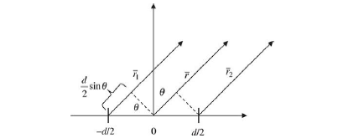

Where

*r1 = r +*

*r2 = r -*

Assuming that the electrical phase of element 1 is –*δ*/2 such that the phasor current in element 1 is *I0 e-. .* The electrical phase of element 2 is + *δ*/2 such that the phasor current in element 2 is *I0 e-.*. We can now find the distant electric field by using superposition as applied to these two dipole elements. Assuming that *r*1 ≈ *r*1 ≈ *r* in the denominator, we can now find the total electric field.

*E θ = +*

*=*

*Where*

*L = dipole length*

*angle as measured from the z axis in spherical coordinates*

*d = element spacing*

Which simplifies further to

*E θ =θ . (2cos ( ))*

where the element factor is the far-field equation for one dipole and the array factor is the pattern function associated with the array geometry. The distant field from an array of identical elements can always be broken down into the product of the element factor (EF) and the array factor (AF). The very fact that the antenna pattern can be multiplied by the array factor pattern demonstrates a property called *pattern multiplication*. Thus, the far-field pattern of any array of antennas is always given by (EF) × (AF). The AF is dependent on the geometric arrangement of the array elements, the spacing of the elements, and the electrical phase of each element.

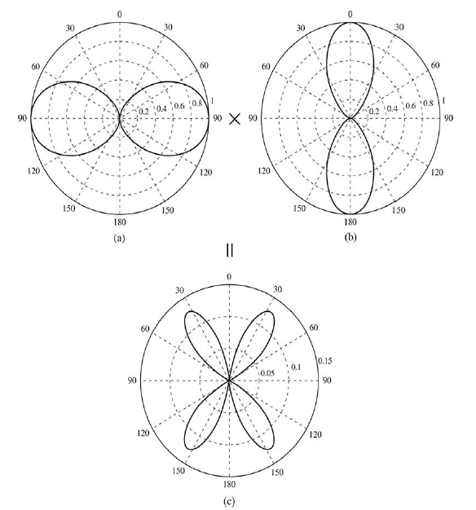

1. Dipole pattern, (*b*) array factor pattern, (*c*) total pattern.

#### Uniform N-Element Linear Array

The more general linear array is the *N*-element array. For simplification purposes, we assume that all elements are equally spaced and have equal amplitudes. It is assumed that the *n*th element leads the (*n* – 1) element by an electrical phase shift of *δ* radians. This phase shift can easily be implemented by shifting the phase of the antenna current for each element.

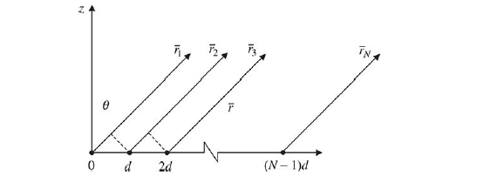

Assuming far-field conditions such that *r* >> *d*, we can derive the array factor as follows:

AF = 1 +

where *δ* is the phase shift from element to element.

This series can more concisely be expressed by

AF = =

where *ψ* = *kd* sin *θ* + *δ*.

The definition of the array vector is given as below

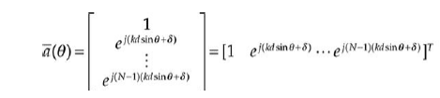

where [ ]*T* signifies the transpose of the vector within the brackets.

The vector is a Vandermonde vector because it is in the form [1 *z* ··· *z*(N–1)]. In the literature the array vector has been alternatively called: the *array steering vector*, the *array propagation vector*, the *array response vector*, and the *array manifold* *vector*. For simplicity’s sake, we call the array vector. Therefore, the array factor, can alternatively be expressed as the sum of the elements of the array vector.

AF = sum (*a* (*θ*))

Which is derived as

AF =

### CIRCULAR ARRAY

The circular array, in which the elements are placed in a circular ring, is an array configuration of very practical interest. Over the years, applications span radio direction finding, air and space navigation, underground propagation, radar, sonar, and many other systems. More recently, circular arrays have been proposed for wireless communication, and in particular for smart antenna. A circular array of *N* elements in the *x*-*y* plane with radius *a* may be shown as below

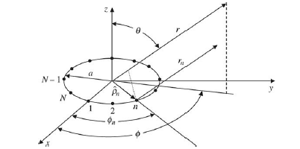

The *n*th array element is located at the radius *a* with the phase angle *ϕn*. Additionally, each element can have an associated weight *wn* and phase *δn*. As before, with the linear array, we assume far-field conditions and will assume that the observation point is such that the position vectors and are parallel. We can now define the unit vector in the direction of each array element *n*.

ρ*n* = cos *ϕn* *x* + sin *ϕn y*

We can also define the unit vector in the direction of the field point.

*r*  = sin *θ* cos *ϕn x* + sin *θ* sin *ϕn y* + cos *θ z*

It can be shown that the distance *rn* is less than the distance *r* by the scalar projection of **ρ*n*** onto *r*. Thus,

*rn* = *r* - *a*ρ*n* ***.*** *r*

with

ρ*n . r* = sin *θ* cos *ϕ* cos *ϕn* + sin *θ* sin *ϕ* sin *ϕn* = sin *θ* cos(*ϕ - ϕn*)

The array factor can now be found in a similar fashion as was done with the linear array.

With some effort, it can be shown that

AF =

Where

*ϕn* =

#### Beamsteered Circular Arrays

The beamsteering of circular arrays is identical in form to the beamsteering of linear arrays. If we beamsteer the circular array to the angles (*θ*0, *ϕ*0), we can determine that the element to element phase angle is *δn* = –*ka* sin*θ*0 cos(*ϕ*0 – *ϕn*). We can thus rewrite thearray factor as

AF =

The circular array AF can be plotted in two or three dimensions. Let us assume that all weights are uniform and that the array is steered to the angles *θ*0 = 30° and *ϕ*0 = 0°. With *N* = 10 and *a* = *λ*, we can plot the elevation pattern in the *ϕ* = 0° plane as shown

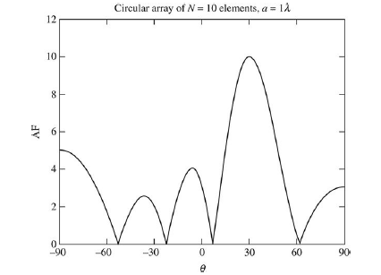

Three-dimensional amplitude pattern of the array factor for a uniform circular array of *N* = 10

elements (*C*∕λ = *ka* = 10).

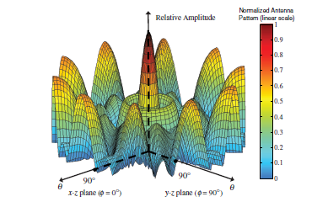

Principal-plane amplitude patterns of the array factor for a uniform circular array of *N* = 10 elements (*C*∕λ = *ka* = 10). 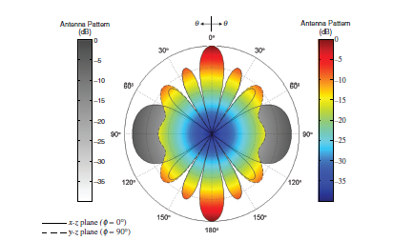

### Rectangular Planar Arrays

Rectangular arrays are slightly more complex geometry patterns for arrays. Below is a rectangular array in the *x*-*y* plane. There are *M* elements in the *x* direction and *N* elements in the *y*-direction creating an *M* × *N* array of elements. The *m*-*n*th element has weight *wmn*. The *x*-directed elements are spaced *apart* and the *y*-directed elements are spaced *dy* apart. The planar array can be viewed as *M* linear arrays of *N* elements or as *N* linear arrays of *M* elements. Because we already know the array factor for an *M* or *N* element array acting alone, we can use pattern multiplication to find the pattern of the entire *M* × *N* element array. Using pattern multiplication, we have

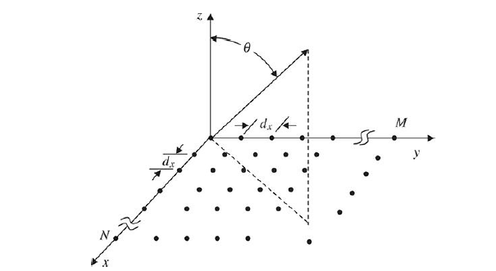

where *ωmn* = *am* · *bn*.

The weights *am* and *bn* can be uniform or can be in any form according to the

designer’s needs. The *am* weights do not have to be identical to the *bn* weights. Thus, we might choose the *am* weights to be binomial weights while the *bn* weights are Gaussian. Any combination of weighting can be used and *ωmn* is merely the consequence of the product *am* · *bn*.

If beamsteering is desired, the phase delays *βx* and *βy* are given by

*βx = -k dx sin βy = -k dy sin*

### BEAM-FORMING

 Beamforming is the process of forming the radiation pattern of the antenna array by nulling out the interference and pointing the beam in the direction of the user. [ref]

#### An adaptive array system consists of consists of antenna array elements terminated in an adaptive processor which is designed to update and compensate array weights as the source moves.

#### Two basic approaches to adaptation are generally used:

#### Block adaptation – a temporal block of data is used to estimate the optimum weights.

#### Continuous adaptation – Antenna weights are adjusted as the data is sampled such that the weight vector converges to an optimum solution.

#### The adaptation process must satisfy certain optimization criterion, such as:

#### Minimizing variance

#### Maximizing the signal to interference ratio

#### Minimizing the mean square error

#### Least Mean Squares Algorithm

The LMS algorithm is a gradient based approach. It is assumes a quadratic performance surface.

The weights are adjusted iteratively by estimating the gradient of the quadratic Mean Square Error surface and adjusting the weights in the negative direction of the gradient by the step size.

The convergence of the LMS algorithm is directly proportional to the step-size parameter μ. If the step size is too small, the convergence is slow and we will have the overdamped case. If the convergence is slower than the changing angles of arrival, it is possible that the adaptive array cannot acquire the signal of interest fast enough to track the changing signal. If the step size is too large, the LMS algorithm will overshoot the optimum weights of interest. This is called the underdamped case. If attempted convergence is too fast, the weights will oscillate about the optimum weights but will not accurately track the solution desired. It is therefore imperative to choose a step size in a range that ensures convergence. It can be shown that stability is ensured provided that the following condition is met [widrow].

where is the largest eigen value of the array correlation matrix (k)which is given by,

x(k) denotes the received signal vector. The array weights are updated according to the following equation.

where the error signal is given by

#### Sample Matrix Inversion

The Sample Matrix Algorithm (SMI) is based on block adaptation. It is also known as Direct Matrix Inversion (DMI).

The sample matrix is a time average estimate of the covariance matrix using K-time samples. If the random process is ergodic in the covariance, the time average estimate will equal the actual covariance matrix.

The weights for the block of length K are calculated using the equation below.

where is the array correlation matrix given by

where K is the observation interval.

This algorithm is suitable for a rapidly changing environment as it converges much faster than the LMS algorithm, thereby allowing the tracking of the desired signal.

However, for large matrices inversion is computationally complex and matrix singularities can also cause a problem for the algorithm.

#### Recursive Least Squares Algorithm

The Recursive Least Squares(RLS) algorithm overcomes the drawbacks of the SMI by recursively calculating the required correlation matrix and the required correlation vector.

For mobile environments where the signal source may be moving, the LMS algorithm converges slowly. This problem is remedied by replacing the gradient step size μ with a gain matrix at the iteration, producing the weight update equation given below

#### Conjugate Gradient Method

The Conjugate Gradient Method has the advantage of increasing the convergence rate by iteratively searching for the optimum solution choosing conjugate paths for each new iteration. This method produces orthogonal search directions resulting in the fastest convergence, that is, the path taken for the iteration is perpendicular to that for the iteration.

The weights are updated according to the following equation

where is the step size and D(n) is the direction vector.

#### Comparison of Beamforming Algorithms

The LMS algorithm has very good performance though it converges rather slowly compared to the SMI algorithm and the others.

The SMI algorithm improves the rate of converges at a cost of more computational complexity and the challenge of array singularities of the correlation matrix.

The RLS overcomes the problems of the SMI and improves the convergence of the LMS at a cost of higher Side Lobe Levels (SLL) and lower null depths.

The CGM algorithm has the fastest convergence and greatest null depths ensuring good performance.

# CHAPTER 3

# METHODOLOGY

Antenna

Linear antenna

Beamformer

Parameters and how to manipulate them

Neural Net

Basic structure

LSTM

Data collection

Data wrangling

Training

Validation

Testing

Deployment

# CHAPTER 4

# EXPECTED RESULTS

# BUDGET

|  |  |
| --- | --- |
| **ITEM** | **COST** (KSH) |
| Microcontroller kit | 5,000.00 |
| GSM modem | 3,000.00 |
| Stationery, printing and binding charges | 1,000.00 |
| Internet connection charges | 1,000.00 |
| **TOTAL** | **10,000.00** |

# WORKING SCHEDULE

|  |  |  |  |  |  |  |  |  |  |
| --- | --- | --- | --- | --- | --- | --- | --- | --- | --- |
| **ASSIGNMENT** | TIME (MONTHS) MAY 201-DECEMBER 2018 | | | | | | | | |
| SEPT | OCT | NOV | DEC | JAN | FEB | MAR | APR | MAY |
| LITERATURE REVIEW |  |  |  |  |  |  |  |  |  |
| PROPOSAL WRITING |  |  |  |  |  |  |  |  |  |
| MINI PRESENTATION |  |  |  |  |  |  |  |  |  |
| DESIGN/ IMPLEMENTATION |  |  |  |  |  |  |  |  |  |
| RESULTS ANALYSIS |  |  |  |  |  |  |  |  |  |
| FINAL PROJECT WRITEUP |  |  |  |  |  |  |  |  |  |
| FINAL PRESENTATION |  |  |  |  |  |  |  |  |  |

# REFERENCES

N. L. et al (2014). *“Connected Vehicles: Solutions and Challenges* (Vol. 1). IEEE Internet Things Journal.

Mikluščák, T., Gregor, M., & Janota, A. (2012). Using Neural Networks for Route and Destination Prediction in Intelligent Transport Systems. Communications in Computer and Information Science, 380–387. https://doi.org/10.1007/978-3-642-34050-5_43

Ziebart, B.D., Maas, A.L., Dey, A.K., Bagnell, J.A.: Navigate Like a Cabbie: ProbabilisticReasoning from Observed Context-Aware Behavior. In: UbiComp 2008 Proceedings ofthe 10th International Conference on Ubiquitous Computing, pp. 322–331 (2008)

Wong, W.K., Xia, M., Chu, W.C.: Adaptive neural network model for time-seriesforecasting. European Journal of Operational Research 207(2), 807–816 (2010)

https://newsroom.intel.com/editorials/self-driving-cars-big-meaning-behind-one-number-4-terabytes/

Krumm, J. 2006. Real time destination prediction based on

efficient routes. No. 2006-01-0811. SAE Technical Paper,

2006.

<https://arxiv.org/pdf/1606.08365.pdf> DSRChttps://arxiv.org/pdf/1606.08365.pdf DSRChttps://arxiv.org/pdf/1606.08365.pdf DSRChttps://arxiv.org/pdf/1606.08365.pdf DSRChttps://arxiv.org/pdf/1606.08365.pdf DSRChttps://arxiv.org/pdf/1606.08365.pdf

Monzingo, R., and T. Miller, Introduction to Adaptive Arrays, Wiley Interscience, John Wiley & Sons, New York,

1980.